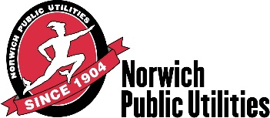

NORWICH BOARD OF PUBLIC UTILITIES’ COMMISSIONERS
SPECIAL MEETING AGENDA
6:00 P.M., Wednesday
September 5, 2017

- Call To Order

- Executive Session – To Discuss Confidential Trade Secret & Commercially Valuable Confidential or Proprietary Information Not Subject to Inspection or Public Disclosure Pursuant to Section 1-210[5] and 7-232a of the CT. General Statutes. This information is confidential and is not subject to public disclosure, pursuant to Public Act No. 98-212, as it relates to personnel matters.

The next Regular Meeting is scheduled to be held on Tuesday, September 26, 2017.

Respectfully Submitted,
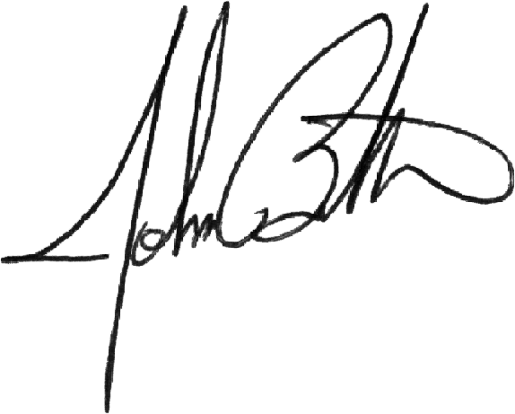

John Bilda
General Manager

