NORWICH PUBLIC UTILITIES – RESIDENTIAL NATURAL GAS EFFICIENCY PROGRAM
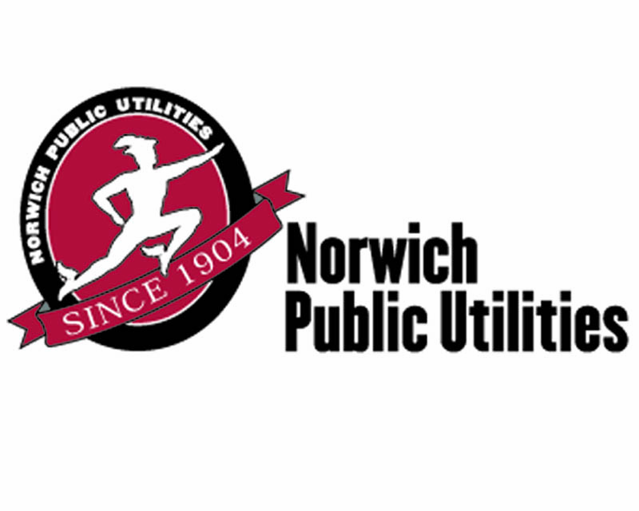
Energy Services: (860) 823-4514
E-Mail: efficiencymatters@npumail.com
www.norwichpublicutilities.com
CUSTOMER INFORMATION
Name: _________________________________________ Contact: ___________________________________________
Mailing Address: ________________________________________ City: __________________ ST: ____ Zip: ________
Installation Address (if different): ________________________________________________________________________
Natural Gas Account Number (for installation address): ______________________________________________________
Phone: ____________________________ Fax: _________________________ E-Mail: ____________________________

By signing below, customer agrees to the conditions as stated on the back of this application and to any special requirements.

Customer Signature:_______________________________________________________ Date: ___________________

CONTRACTOR INFORMATION
Company Name: ___________________________________ Contact: _________________________________________
Mailing Address: _______________________________________ City: ___________________ ST: _____ Zip: ________
Phone: ____________________________ Fax: _________________________ E-Mail: ____________________________

By signing below, customer agrees to the conditions as stated on the back of this application and to any special requirements.

Contractor Signature:_______________________________________________________ Date: ___________________

APPLICATION INSTRUCTIONS
(Applications will not be processed without providing all applicable information)
- Read Initiative Requirements on the reverse side of this application. Use Efficiency and Incentive Levels to determine eligibility and rebate amount for your equipment purchase(s). NPU reserves the right to provide the rebate in the form of a credit adjustment on your natural gas account. | - Attach invoice showing proof of purchase and installation, manufacturer’s specification sheet with equipment make, model, size and efficiency rating, and a final letter of compliance from the building department. NPU reserves the right to conduct field inspections to verify proper installation of equipment.
- Fill out all applicable spaces on the application. Both the customer and contractor musts sign the application. | - Send all documentation to NPU – Natural Gas Rebate Program, 16 South Golden Street, Norwich, CT 06360.

EQUIPMENT INSTALLED AND REBATE AMOUNT

Reason  N = New  R=  Replacement | Equipment Code  (from back side of form) | Manufacturer  & Model  Number | Boiler/FurnaceUnit Size  (BTU) | Efficiency  (AFUE , Thermal Efficiency or EF) | Max. Flow Rate at 65ºF Temp Rise (GPM)  (for on demand tankless water heaters) | Qty Installed | Rebate Amount  Requested
Example  N | HWB | Acme, HV1011 | 300,000 | 90% |  | 1 | $600

TOTAL REBATE

Please check here if you prefer your rebate in the form of a credit adjustment on your natural gas account.

Customer Check List:

Completed Rebate Form Invoice showing proof of purchase and installation Equipment Specification Sheet Letter of Compliance

FOR ADMINISTRATIVE USE ONLY:
 | Inspection Date: |  |  | Inspected by:
Project ID: |  | Database ID #: | Approved  Rebate: $ |  | Approving  Signature:

RESIDENTIAL EFFICIENCY AND REBATE LEVELS
FURNACES
Equipment Code | Type | Heating Capacity (BTU) | Minimum Efficiency | Rebate
WAF | Condensing Warm Air Furnace | ≤ 150,000 | 95% AFUE | $400
BOILERS
Equipment Code | Type | Heating Capacity (BTU) | Minimum Efficiency | Rebate
HWB | Condensing Hot Water Boiler | ≤ 300,000 | 90% AFUE | $600
THWB | Tankless Hot Water Boiler | ≤ 300,000 | 90% AFUE | $600
COMBI | Tankless Boiler / Water Heater Combined | ≤ 300,000/  < 4 GPM | 90% AFUE | $850
COMBI | Tankless Boiler / Water Heater Combined | ≤ 300,000 /  > 4 GPM | 90% AFUE | $1,050
WATER HEATERS
Equipment Code | Type | Flow Rate at 65°F Rise (GPM) | Minimum Efficiency | Rebate
WH-ODT | On Demand Tankless Water Heater | < 4 | .82 Energy Factor | $250
WH-ODT | On Demand Tankless Water Heater | ≥ 4 | .82 Energy Factor | $450
WH-IF | Indirect Fired Water Heater | N/A | 90% Thermal Efficiency | $250

RESIDENTIAL PROGRAM REQUIREMENTS

Eligibility: This rebate form is intended for residential one to three family homes ONLY. For projects larger than three family homes or for commercial and industrial projects, please call 860-823-4153 for more information.
Rebates are available to residential natural gas service customers of Norwich Public Utilities. Equipment must be installed in the service territory of Norwich Public Utilities. For commercial and industrial projects, call 860-823-4153for information and assistance.
Application Offer: Details of this program, including rebate levels, are subject to change or cancellation without prior notice. Completed and signed applications must be submitted within 30 days of the equipment installation to be eligible for rebates. Call (860) 823-4514 for additional information.
Proof of Purchase: An invoice itemizing the purchased equipment must accompany each rebate application form. The invoice copy must indicate the equipment type, size, make and model, serial number of the system and date of purchase.
Application Form: This application must be filled out completely, truthfully and accurately. An authorized representative of the customer must sign, date, and submit the application along with the invoice, and manufacturer’s equipment performance sheet stating the ARI certified efficiency rating and nominal capacity. To qualify for a Gas Efficiency Rebate, a copy of the final letter of compliance from the Building Department must be supplied with this application.
Payment: Please allow 30 days for payment. Payment process may take longer if information is missing on application. Call (860) 823-4514 for details.
Approval and Verification: Pre-approval from Norwich Public Utilities will be required if the rebate total is greater than $6,000. Norwich Public Utilities reserves the right to verify sales transactions and to have reasonable access to your facility to inspect the equipment installed under this program, prior to issuing rebates or at a later time.
Endorsement: Norwich Public Utilities does not endorse any particular manufacturer, product or system design in promoting this initiative.
Tax Liability: Norwich Public Utilities will not be responsible for any tax liability that may be imposed on the customer as a result of the payment of rebates.
Warranties: NORWICH PUBLIC UTILITIES DOES NOT WARRANT THE PERFORMANCE OF INSTALLED EQUIPMENT, EXPRESSLY OR IMPLICITY. Norwich Public Utilities makes no warranties or representation of any kind, whether statutory, expressed or implied, including, without limitations, warranties of merchantability or fitness for particular purpose regarding equipment or services provided by a manufacturer or vendor. Contact your contractor for details regarding equipment performance and warranties.
Limitations of Liability: The liability of Norwich Public Utilities is limited to paying the rebate specified. Norwich Public Utilities reserves the right to modify or suspend this rebate at any time. Norwich Public Utilities is not liable for any consequential or incidental damages or for any damages in tort connected with or resulting from participation in this Initiative.
Owner/Contractor’s Certification: Owner/Contractor certifies that he/she has purchased and installed the equipment listed above at the defined location. Owner/Contractor agrees that all information is true and that he/she conformed to all initiative and eligibility requirements listed. Owner/Contractor has verified that the units listed above have been installed correctly. There are no unusual noises or vibrations and all controls have been calibrated. Owner/Contractor or owner’s representative has been instructed on how to operate and maintain this equipment and has received all the necessary operation and maintenance manuals. Owner/Contractor has verified that any applicable air-system and water balancing has been performed.
NPU reserves the right to provide rebate in the form of a credit adjustment on your natural gas account.

