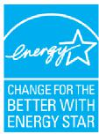
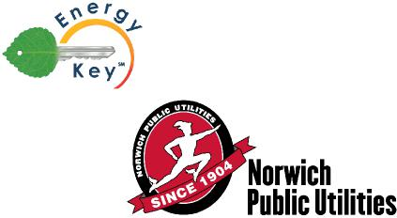
Home Energy Savings Program 2014 Mail-in Rebate
Up to $500 off
ENERGY STAR® Electric Water Heaters
For Norwich Public Utilities Electric Customers Only

The Energy Star® Electric Water Heater Mail-in Rebate
Get up to $500 back from your Norwich Public Utilities when you purchase an eligible Energy Star® high efficiency electric water heater. This rebate is good for purchases made from January 1, 2014 - December 31, 2014. LIMIT: One rebate application per NPU electric utility account
To receive your rebate:
- Fill out this form completely.
- Enclose a copy of a dated sales receipt showing model # of appliance(s), a copy of the yellow energy guide label, and a copy of a recent electric bill. Incomplete or missing information will delay or disqualify your rebate.
- Mail to: NPU-Appliance Rebate, 16 South Golden Street, Norwich, CT 06360
Please DO NOT include this rebate form with your utility bill payment. All rebate requests must be postmarked no later than January 15, 2015.
NPU reserves the right to provide the rebate in the form of a credit adjustment on your electric account.
Customer Information
Please fill out completely. All information below is required.
Phone #
Mailing Address

Email
Name
Zip
State
City
Electric Account Number
(at the installation address)
Installation Address
(if different from mailing address)

.
Storage Tank Water Heater
59-gallon or smaller tank must have an energy factor of 0.93 or greater; 60-gallon or larger tank must have an energy factor of 0.91 or greater
.

Appliance Information
Qualifying appliances must be Energy Star ® rated. Provide the following information for each purchase:
Heat Pump Water Heater
Model #
$500
Manufacturer
Purchase Date
Place of Purchase
(Name and City)
Check here if you wish to have rebate provided in the form of a credit adjustment on your electric account
Customer Signature
$60
Model #
Manufacturer
ENERGY STAR® qualified appliances save energy and money, and help protect the environment.
Join the national effort to help use energy wisely. Buy appliances that have earned the Energy Star® rating. Only products delivering the highest level of energy efficiency are awarded the Energy Star® from the U.S. Environmental Protection Agency and the U.S. Department of Energy.

What’s so important about Energy Star® qualified appliances?

Saving energy also saves money. By using energy efficient products, the average household can save up to $400 per year on utility bills. (Savings are estimated - actual savings my vary.)

According to the U.S. EPA, if just 10% of us used Energy Star® appliances, together we would reduce carbon dioxide pollution by the equivalent of planting 1.7 million acres of new trees.

For more information about Norwich Public Utilities energy efficiency programs, please visit www.norwichpublicutilities.com.

Rebate Requirements

This rebate offer is available to all Norwich Public Utilities electric customers. Limit: One rebate application per appliance per municipal electric utility account. Eligible appliances must be installed at a location in the Norwich Public Utilities service territory. Valid for purchases made between January 1, 2014 and December 31, 2014. All rebate requests must be postmarked no later than January 15, 2015. Norwich Public Utilities reserves the right to conduct field inspections to verify installations. Please allow 30 days for payment; payment process may take longer if application is incomplete or required information is not included. NPU reserves the right to provide the rebate in the form of a credit adjustment on your electric account.

Warranties: NORWICH PUBLIC UTILITIES DOES NOT WARRANT THE PERFORMANCE OF INSTALLED EQUIPMENT, EXPRESSLY OR IMPLICITLY. Norwich Public Utilities makes no warranties or representation of any kind, whether statutory, expressed or implied, including, without limitations, warranties of merchantability or fitness for particular purpose regarding the equipment or services provided by a contractor or vendor. Consult your contractor or vendor for details regarding performance and warranties.

Questions? Contact NPU at (860) 823-4514 or email us at efficiencymatters@npumail.com.

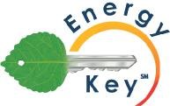
Energy Key is a service mark of the Connecticut Municipal Electric Energy Cooperative. Participants include Norwich Public Utilities, Groton Public Utilities, Bozrah Light & Power Company, Jewett City Department of Public Utilities, South Norwalk Electric & Water, Third Taxing District Electric Department, and Wallingford Electric Division. Visit www.cmeec.com for more information.

